
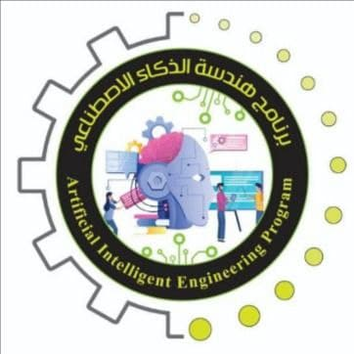
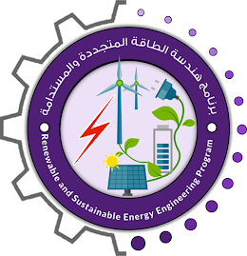

Robotics Project
Project members | ID number
Mostafa Saad Abdo Shaheen | 805498138
Adel Mahmoud Adel Shousha | 806237372
Mahmoud Mohamed Mahmoud Sadeq | 805544800
Youssef Ahmed Farouk Elkotby | 808962813
Mohamed Ibrahim Taha Mohamed | 806127660
Ramy Waleed Abdullah Al-Baqiry | 805774428
Karim Atef Gamal Mashaly | 806147227
Mazen Ayman Abdel-Aziz Awad | 805502582
Ahmed Mohammed Ahmed Foda | 805495108
Omar Amir Elmasry Zidane | 805495104
Mazen Amir Mohamed Bakry | 805542174
Abdallah ElHoseny Rashad | 806147735

Under Supervision of:
Dr. Ahmed Sameh

